Assignment 1

R-1.1 Graph the functions 12n, 6n log n, n2, n3, and 2n using logarithmic scale for the x- and y-axes; that is, if the function value f(n) is y, plot this as a point with x-coordinate at log n and y-coordinate at log y.

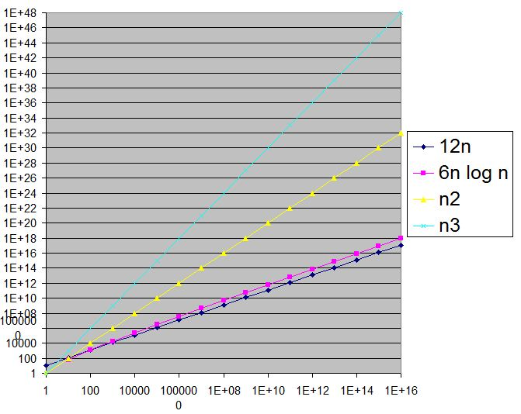

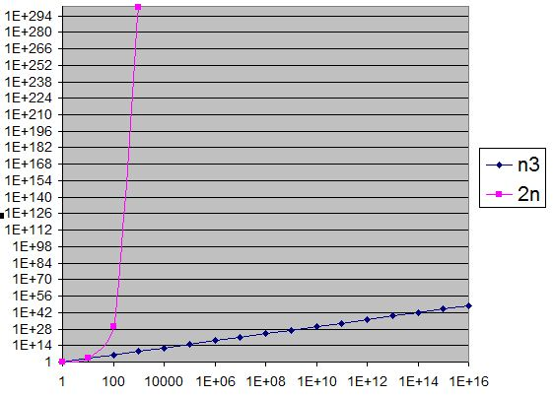

R-1.2 Algorithm A uses 10n log n operations, while algorithm B uses n2 operations. Determine the value n0 such that A is better than B for n ≥ n0.

With n >= n0 = 59, the algorithm A is better than the B

R-1.6 Order the following list of functions by the big-O notation. n log n log log n 1/n 4n3/2 5n 2n log2 n 2n 4n n3 n2 log n 4log n √n

1/n < loglogn < n1/2 < nlogn < 5n < 4nn1/2 < 4logn < 2nlog2n < n2logn < n3 < 2n < 4n

R-1.10 Give a big-O characterization, in terms of n, of the running time of the Loop1 method below: Algorithm Loop1(n)

s ← 0 1

for i ← 1 to n do n

s ← s + i n

Total running time = O(n)

R-1.14 Perform a similar analysis for method Loop5 below:

Algorithm Loop5(n)

s ← 0 1

for i ← 1 to n2 do n2

for j ← 1 to i do n2(n2+1)/2

s ← s + i n2(n2+1)/2

Total running time = O(n4)

Prove: logb xa = a logb x

Assume that y = logb x

=> x = by => xa = (by)a => logb xa  = logb(by)a  = ya

=> logb xa  = a logb x